Reporting tool



Date | Version | Modifications | Préparé par | Vérifié par | Approuvé par
03/03/2016 | 1.0 | Edition initiale | HSA | BRI
12/16/2016 | C |  | FRV

Object
This manual explains how to use the reporting tool to generate report.

Author | Hannane SAMI
Reference | User Manual
State | Première édition
Version | C.0
Date | 12/16/2016

Contents
Object 2
Contents 3
1 Reporting tool 4
1.1 Requirement 4
1.2 Configuration of reporting tool 4
1.3 Word Generation 11

Reporting tool

Requirement
Reporting tool need specific files and folder on your computer.

It is necessary to copy the monthly report and inverter file locally on the computer (see below).

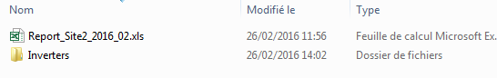

Configuration of Reporting Tool
WARNING
First of all, make a copy of “_Monthly Report.xlsm”, named it according to the site and the first month/year concerned like “Site_Monthly Report Month Year.xlsm” and saved the reporting tool in the concerned folder.

- Open the file “Site_Monthly Report Month Year.xlsm”
- You have to know the power peak and the number of inverters before doing the next steps
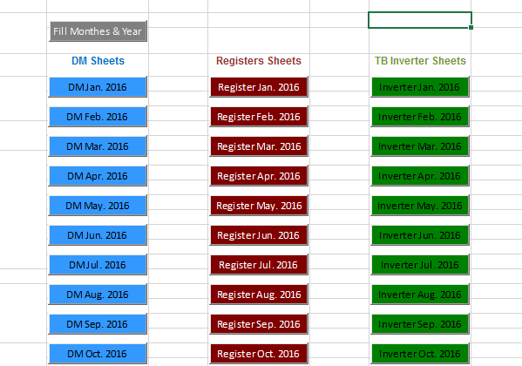

- Click on “Fill Months & Year”
A popup will be displayed (see below)

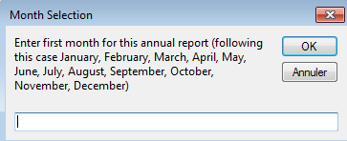

- Enter the month for the annual report (be careful to the capital letter)
- Click on “OK”

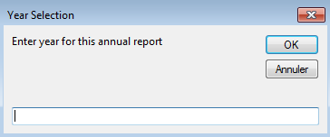

- Enter the year
- Click on “OK”

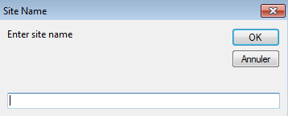

- Enter the name of site
- Click on OK

- Select the tab « DM Month Year » to fill the month required.

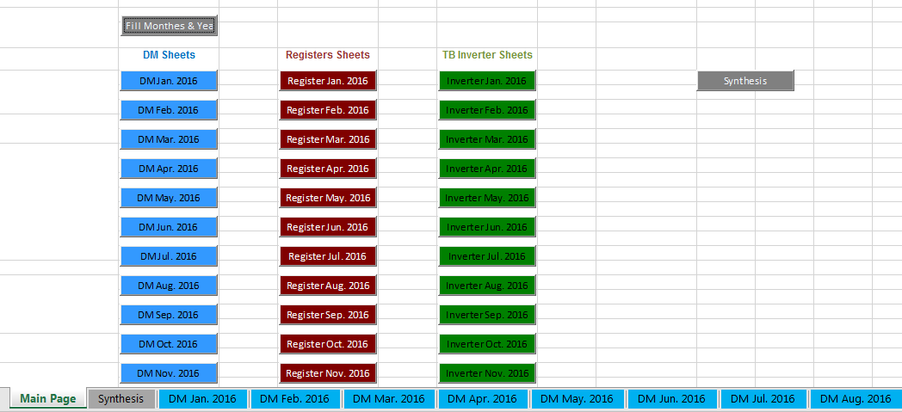

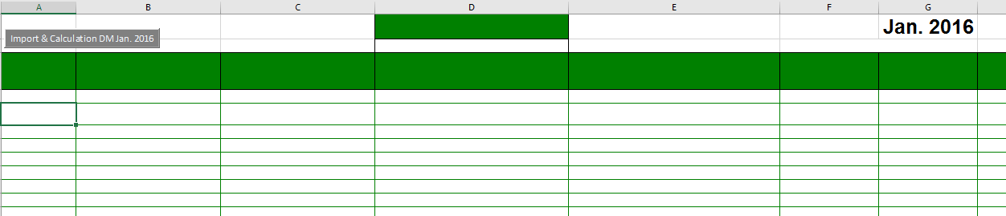

- Click on “Import & Calculation DM Month Year” to import the monthly report and inverter file

- Select the monthly report of the site
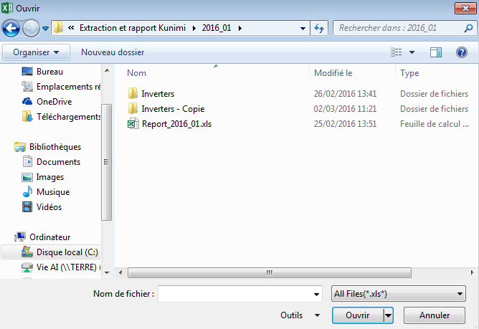

- Click on “Open”
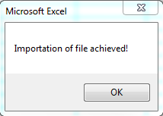

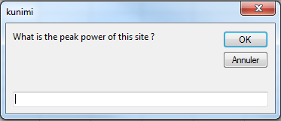

- Fill the peak power of the site
- Click on “OK”

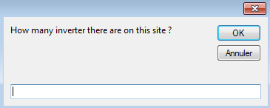

- Fill Site number of inverter
- Click on “OK”

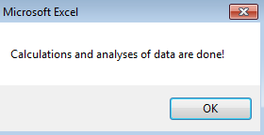

Monthly report is imported on tab “DM Monthly Year”

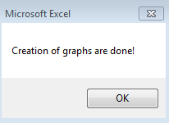

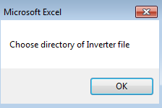

- Then select the folder inverter

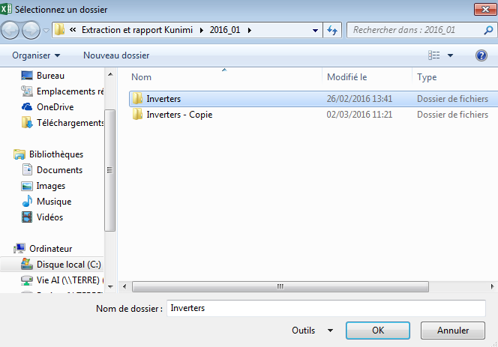

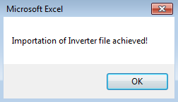

- Click on “OK”
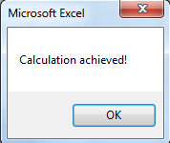

- Inverter file are imported in the tab “inverter month year”
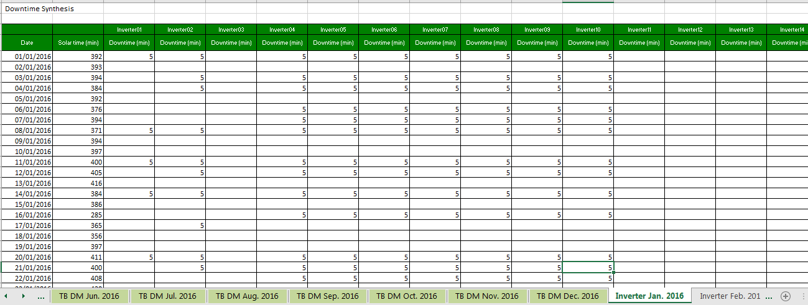

Then it is possible to manually affect downtime Schneider for each inverter
At the end click on “calculation after manually downtime” near the first inverter table

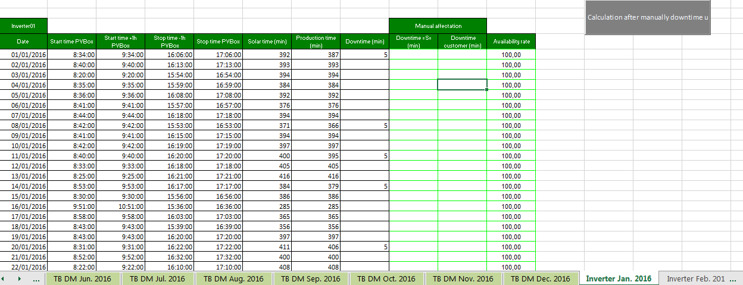

- Select “DM Month year” to see the synthesis of the month.
- Access the tab “Synthesis”

- Click on button “Generate Synthesis” to fill the data for several month
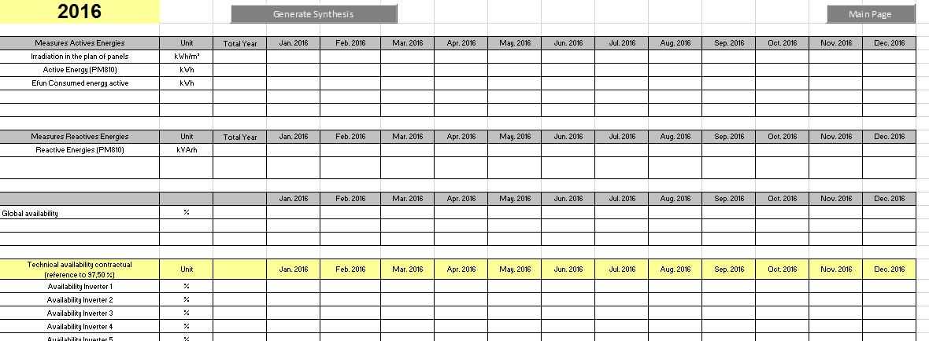

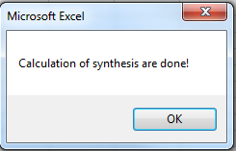

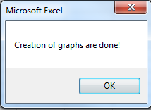

Word Report Generation

Once the different tab is filled, it is possible to generate monthly document in word format.

First of all, make a copy of “_Monthly Report.docm” and named it according to the site and the month/year concerned like “Site_Monthly Report Month Year.docm”.

Select tab “DM Month year” and click on “Generate Report DM Month year”

Select document copied in first “Site_Monthly Report Month Year.docm” and click on OK

The document is automatically filled with the different data from the excel.

